**CMP 4271: Session 12 Online Diary – Digital to Physical**

**8.0 Introduction**

The aim of the game is to catch and evolve Pokémon and reach the Battle Zone and defeat other players’ Pokémon to win.

**8.1 Rules and Mechanics**

**How to Play**

* At the start of each game, the 2-4 players each roll both D6 dice, and the players choose their starting Pokémon card in descending order of their dice rolls (highest roll chooses first). This is also the order that the players take their turns
* The starting Pokémon are Charmander, Squirtle, Bulbasaur and Pikachu.
* Players take turns to move either forwards or backwards around the board (Figure 8.1) in their current zone, rolling a single D6 die to determine how many spaces they move.
* If a player lands on a square with an icon, use Table 8.1: Board Squares to see what action the player takes.
* If two players land on the same square, they enter a battle with their current Pokémon. The winner of this battle can evolve one of their Pokémon.
* Once one player uses both Move Zone squares to get to the Battle Zone, all players enter a turn-based Battle, and the last player wins the game.

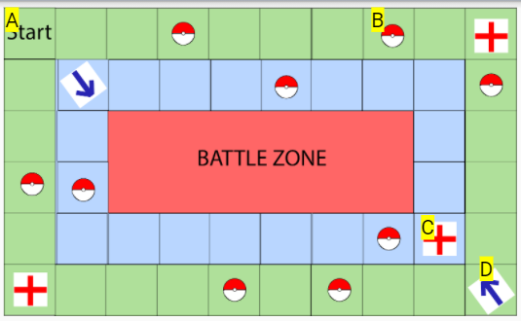

Figure 8.1. The game Board, showing A – Player start location, B – Pokéball space, C – Pokémon Center space, D – Zone Move space. It also shows the three colour-coded zones: Outer (green), Inner (blue) and Battle Zone (red).

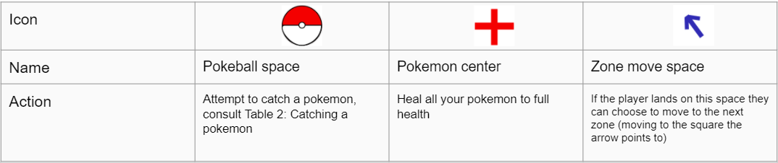Table 8.1: Board Squares

**Catching a Pokémon**

* When a player lands on a Pokéball square, they have the chance to catch a new Pokémon. To catch a Pokémon, the player will choose which Pokémon they want to catch from the table (Table 8.2) included with the game. The player will then roll the two D6 dice to determine if they catch the Pokémon and, if so, which evolution they catch.

Table 8.2: Catching Pokémon. A table to shows the name, stage and minimum dice roll required to catch each Pokémon, with Charmander and its evolutions as an example.

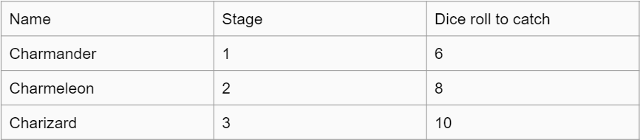

**Battles**

* At the start of a battle, players each choose one of their Pokémon and roll one D6 die.
* The player with the higher die roll deals damage to the opponent equal to their Pokémon’s attack, minus the opponent’s defence. (e.g. 80 Attack to 20 Defence deals 60 Damage). This amount of damage is taken from the HP of the opponent’s Pokémon.
* If a Pokémon is reduced to 0HP, it is knocked out and the player must replace it with another of their Pokémon.
* Players then take turns to fight until one player forfeits or has no remaining Pokémon. This player loses the Battle.

**Cards**

* Each Pokémon available has a card that shows their name and stats and has a layout similar to Table 8.3. Evolutions of each Pokémon have individual cards.

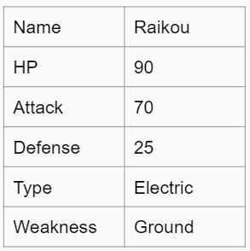Table 3: Example card. A table showing the layout of Raikou’s cards, showing its Health Points, Attack, Defence, Type and Weakness.

**8.2 Play Testing**

Play testing for the game was carried out by Sienna Jenkins. The feedback given was as follows, “The game was quite complicated, especially for players who have not played Pokémon before”.  This was mainly due to limited time for playtesting, which meant the game could not be fully explained.  However, she felt “[…] without the time constraints, [the game] would be easier to understand” as it would allow the game to be fully explained.

**8.3 Working in a Team and Reflection**

For this task, the team worked well together, as different members carried out different tasks such as writing out rules and mechanics, creating diagrams, and creating tables. This was effective in getting the task completed in time, however it could have been improved by allowing more time for play testing which would have allowed the game to be evolved.

**8.4a Team Members**

Jamie Smith

Cory Arnett-O’Brien

Rowan Noble

**8.4b External Play Testing**

Sienna Jenkins